**Image base age and gender classification using convolutional neural network**

**Group No: 7**

**Group members:**

1) AKSHAY POTDAR (220960925036)

2) PRANITA DIBE (220960925037)

3) PRATIKSHA SALUNKE (220960925038)

4) PUNAWESH SAWANT (220960925039)

5) TUSHAR SALVE (220960925040)

**Steps Followed For Feature Extraction**

***1.Our Dataset Is:***

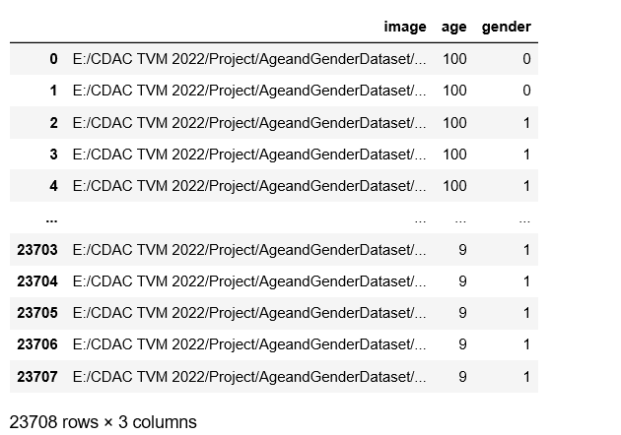

***2.Data Pre-Processing Steps:***

a) Checking for missing values in dataset

b) Calculation of various aggregation functions

c) Treating the missing

d) Overall data description and analysis

***3. Analysis Method Done To Select Features:***

a) Load the Dataset

b) Exploratory Data Analysis

c) Visualizing the data

d) Change age and gender mapping

e) CNN Model Creation

* 1. Reading the images.
  2. Decode JPEG content into an RGB grid of pixels.
  3. Converting into Floating points tensors taking input to neural network

f) Age classification

-Predicting the Age

g) Gender classification

-Predicting the Gender

h) Plot the Model Results

***4.Final Dataset For Processing Would Contain Following Feature***

a) [‘’Image', Age', 'Gender']

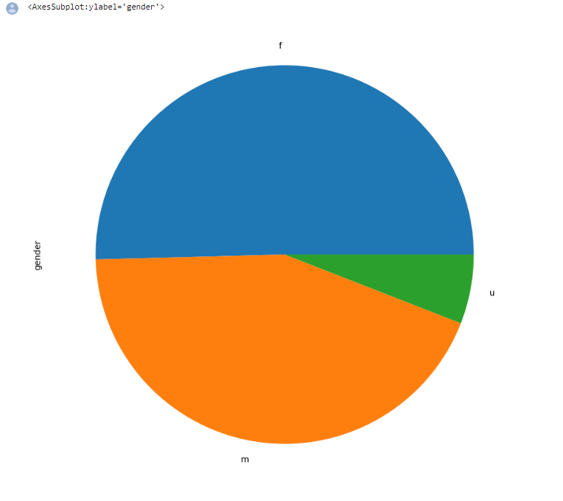

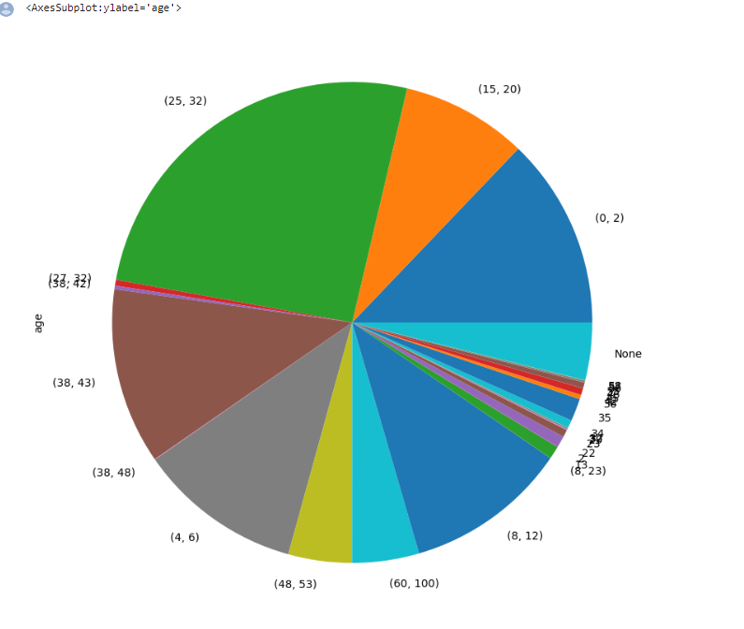

***5. Target Variable:***

To predict age and gender.